Week 2 Practical — Network Topologies and Connections
Star topology

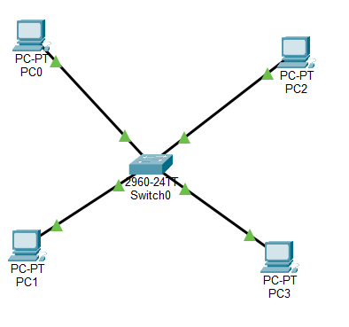

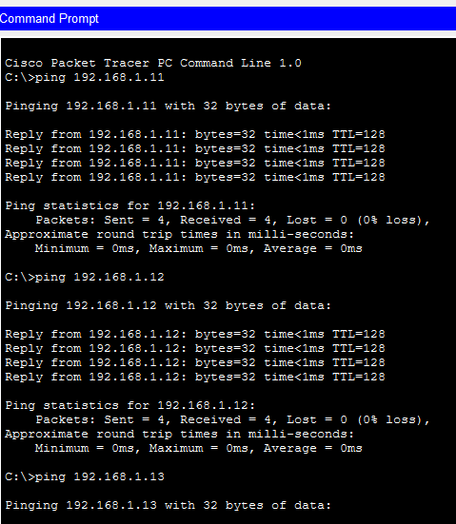

Configurations

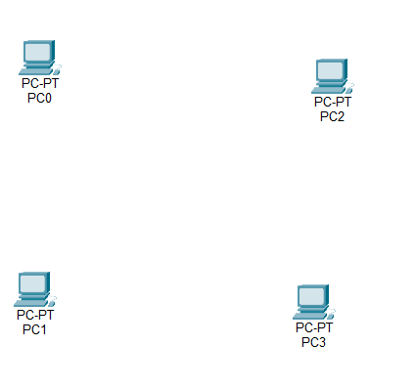
Deleted the cisco switch
Immediate Loss of Connectivity the PCs can no longer communicate directly over the network, rendering local file sharing, printing, or network access inactive.

Q2. No, it’s not, in this case when I removed the switch the network connectivity got lost.

Task 2 Partial Mesh Topology

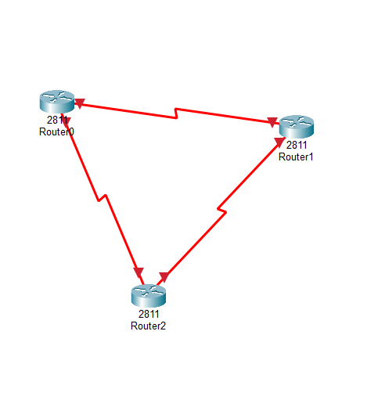

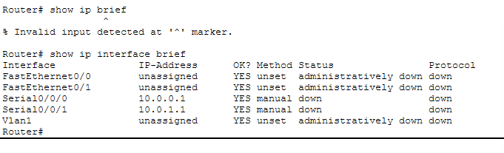

2.4 Redundancy
Question 3
Yes, the interconnection between devices takes over when on router fails.

Question 4
In a star topology, all devices connect to a central hub or switch. If one peripheral device fails, the rest of the network keeps working. But if the central hub fails, the entire network goes down — making it a single point of failure.

In a partial mesh topology, some devices are interconnected directly, while others connect through fewer links. This means there are multiple paths for data to travel. If one link or device fails, data can often be rerouted through another path. It reduces dependency on a single hub, improving fault tolerance compared to star topology.

Question 5
In a full mesh, every device must be directly connected to every other device. As the number of devices grows, the number of required connections increases rapidly

